The Earliest Electric Washing Machine: Help Wanted
By: Lee Maxwell
Asking the question, “Who invented the electric washing machine?” is tantamount to asking, “Who first connected an electric motor to a washing machine?” Electric motors have been around since the 1830s and so have washing machines. We will never discover who it was that made the connection.
Included in this open-ended article is (and will be) authentic evidence of early electric washing machines. Until a more extensive search has been conducted these data are not listed in chronological order. If the reader has any verifiable evidence to add to this list please send an email to . Your contribution will be highly appreciated and you will be credited with the addition.
1907:
The best evidence is a picture like the one following. It appears in an article by B. D. Flower in the December 1907 issue of The Arena, No. 217, page 593. The picture shows a lady reading a newspaper while her washing is done by an electric powered washing machine manufactured by the Nineteen Hundred (1900) Company.
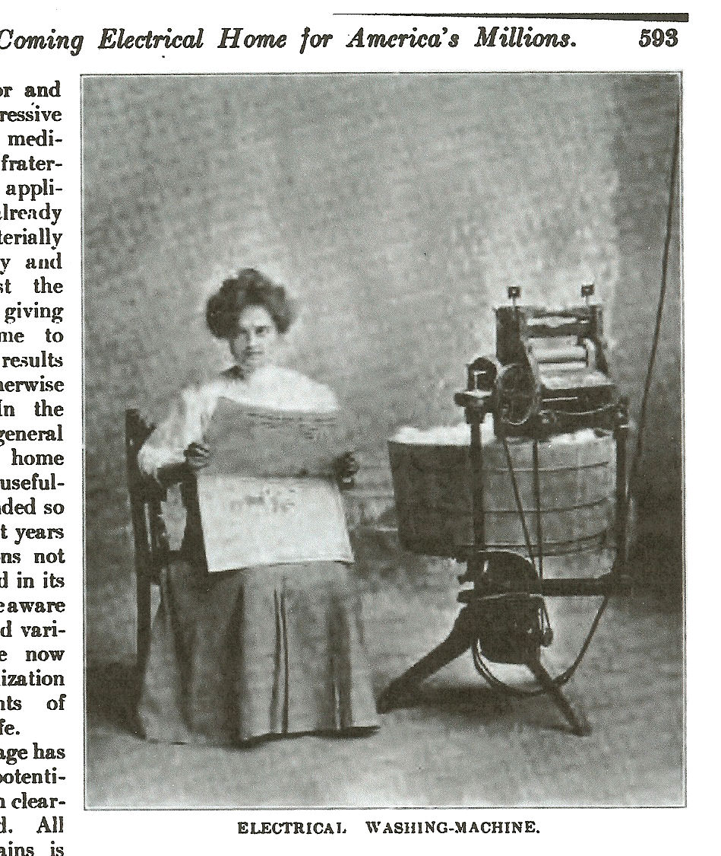

1906-1907:
The picture shown following is from an article by H. W. Hillman, “Electricity in the Home” in the November, 1906-April, 1907 issue of Cassier’s Magazine, Volume XXXI. The picture shows a Nineteen Hundred Company washing machine belted to an electric motor. Note how easily the motor could have been bolted to the board at the bottom of the washing machine tub.
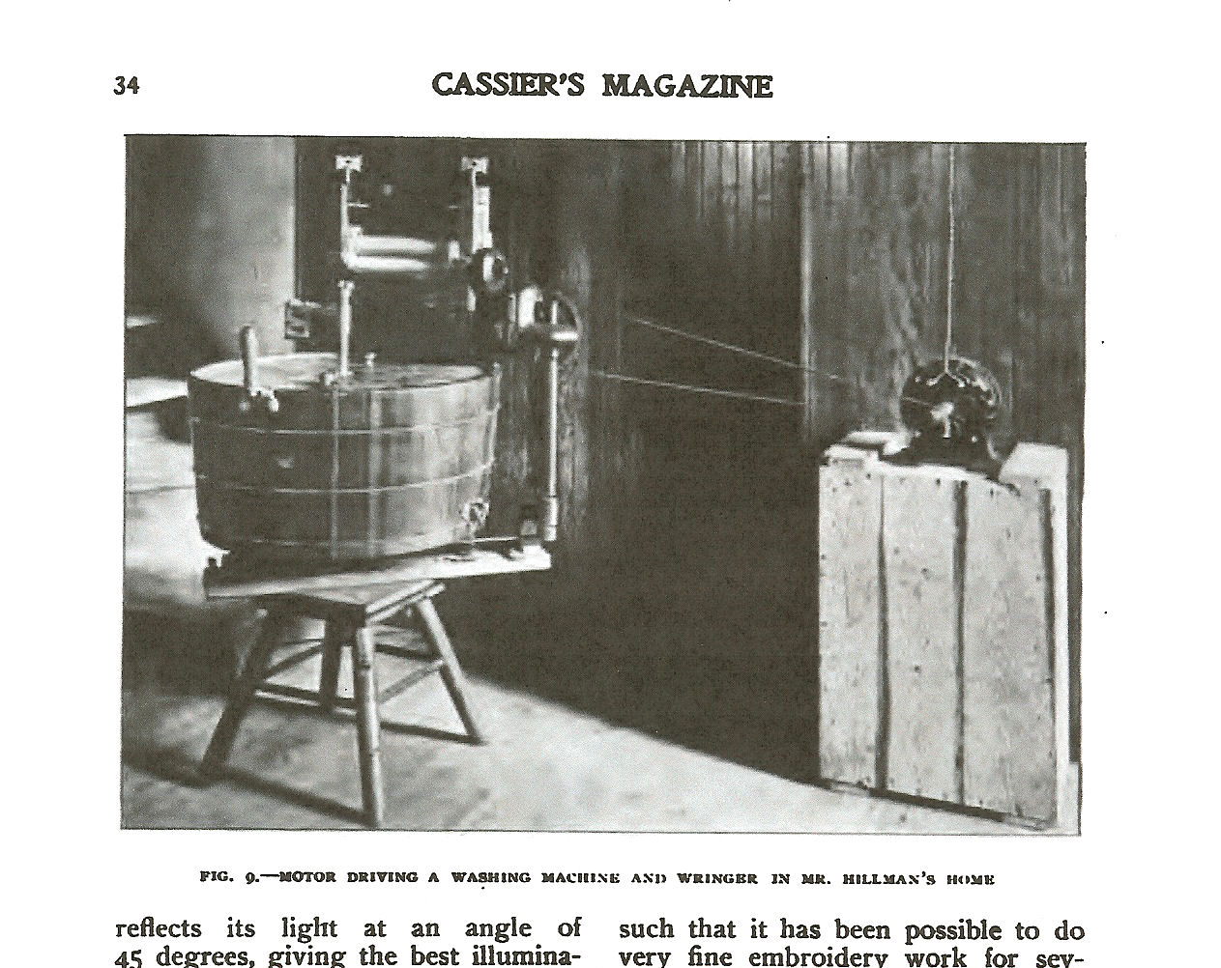

1894:
The following is a picture of a butter churn belted to an electric motor. In the era of 1894 devices were manufactured which could be used either as a butter churn or a washing machine. Unfortunately for the purpose here, the caption of the picture is “Electric Churn.” The appetite is only whetted to find a picture labeled “Electric Washing Machine” of this vintage.
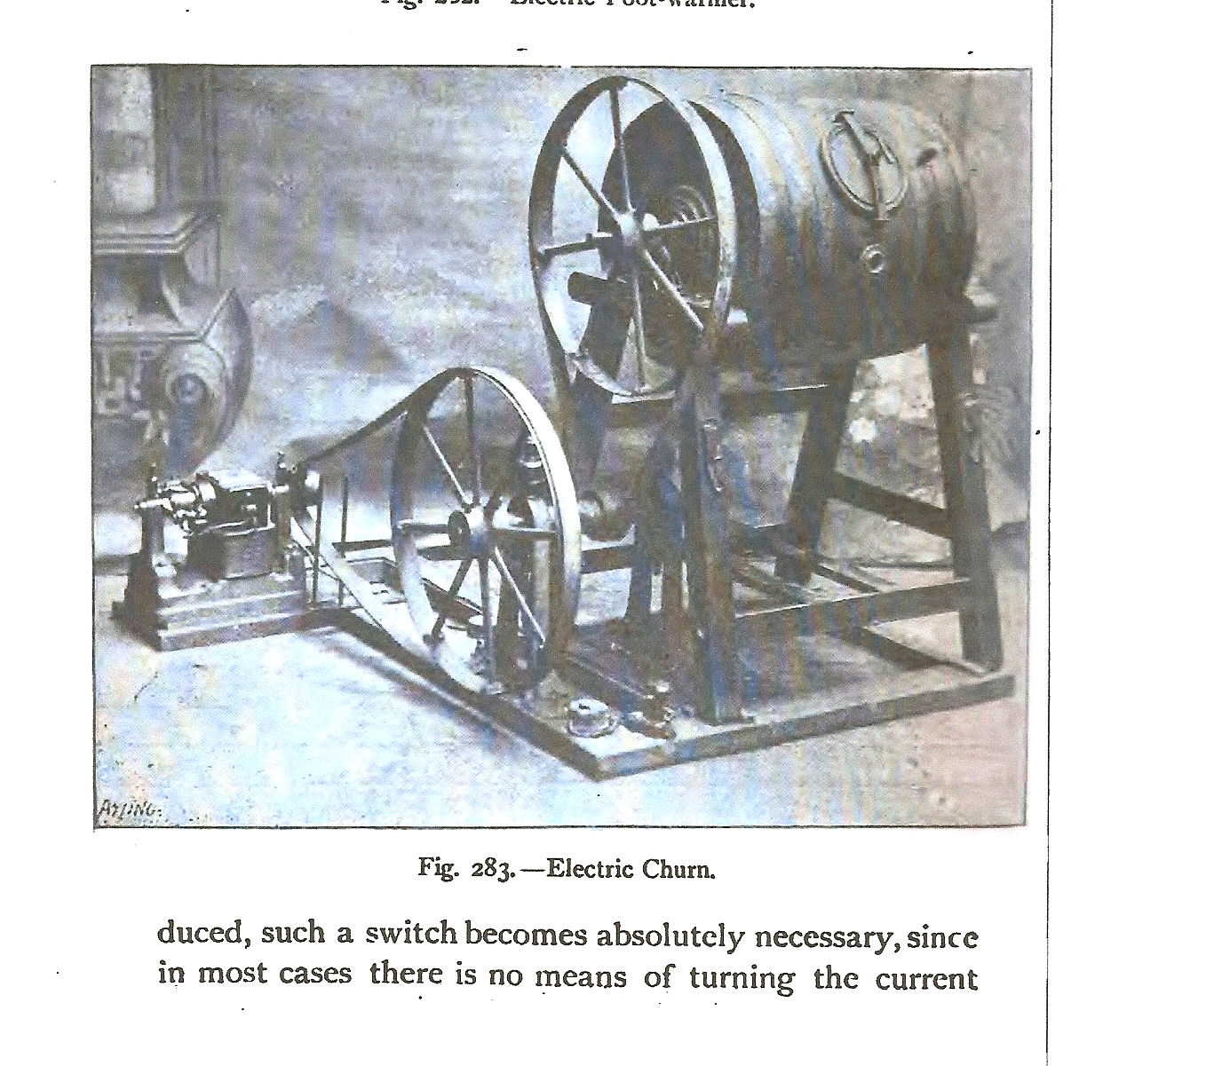
1873: The following two pages illustrate only a text reference to an “electric washing machine” but the 1873 date is an early one.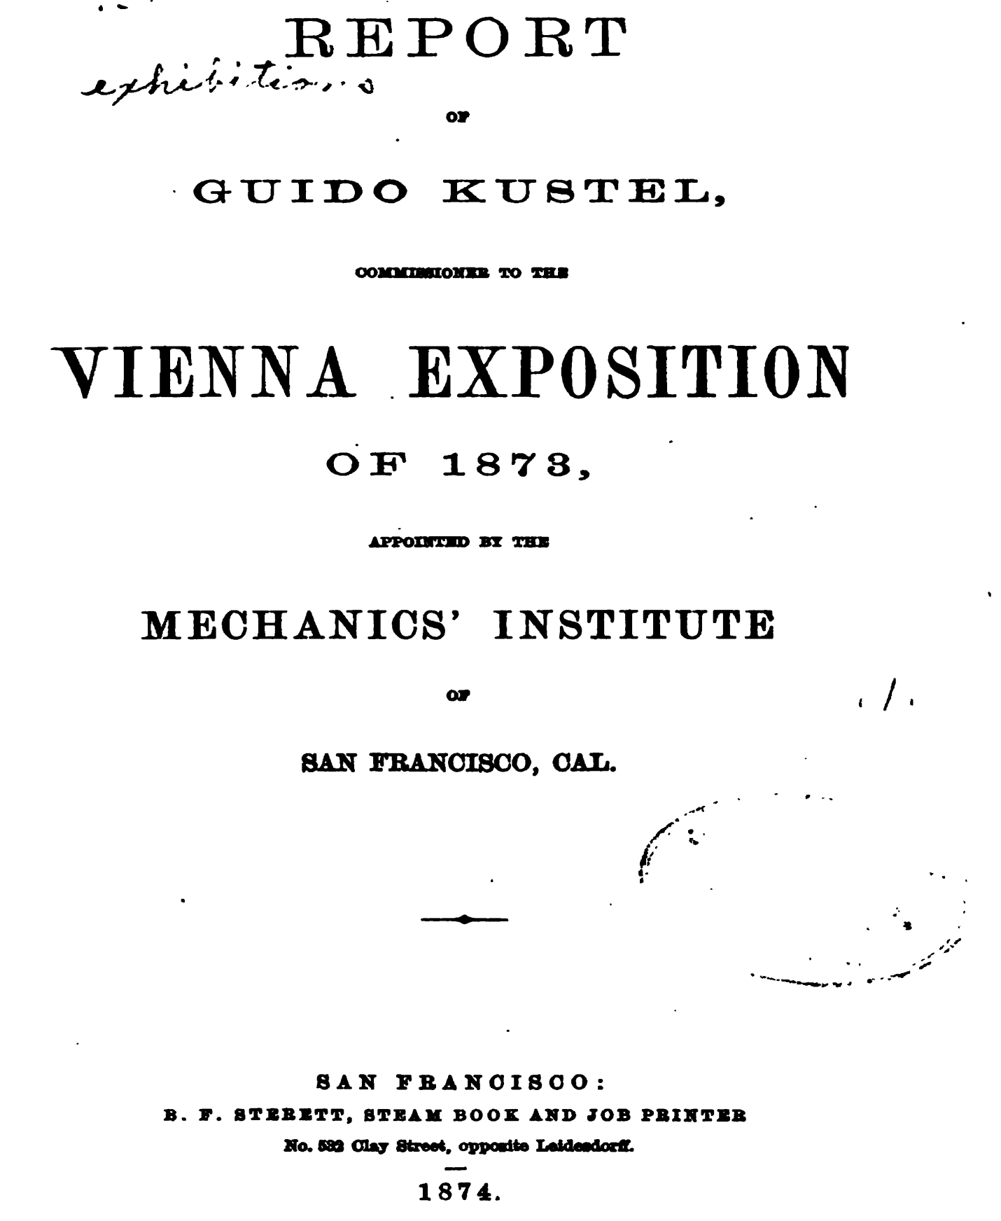
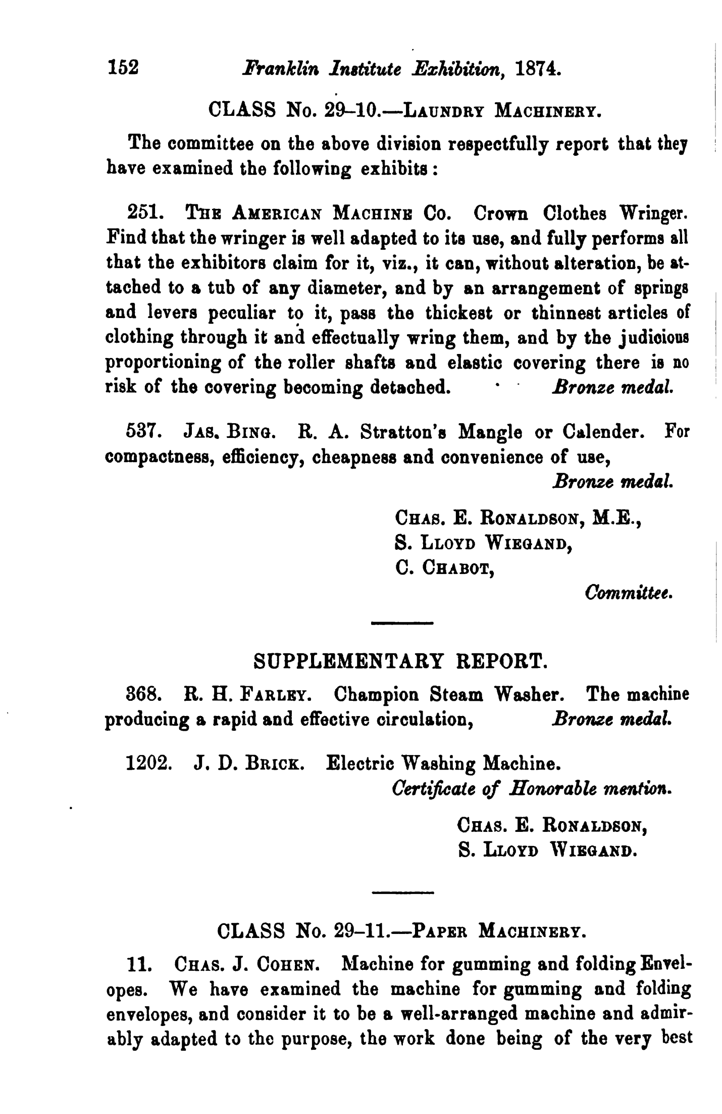
More evidence to be added. (Last entry May 12, 2008)

